**IBM NALAIYATHIRAN PROJECT REPORT**

**Domain :** Retails and E-Commerce (R&E)

**Title:** Customer Care Registry

*Submitted by*

**Team ID:** PNT2022TMID10772

**Team Members:**

M. Prasannakumar

S. Praveen  
S. Pradeep

S. Pragadeesh

|  |  |  |
| --- | --- | --- |
| **Industry Mentor(s) Name** | **:** | Vasudeva Hanush |
| **Faculty Mentor(s) Name** | **:** | Dharani Devi P |

**Project Overview**

1. **INTRODUCTION** 
   1. Project Overview
   2. Purpose
2. **LITERATURE SURVEY**
   1. Existing problem
   2. References
   3. Problem Statement Definition
3. **IDEATION & PROPOSED SOLUTION**
   1. Empathy Map Canvas
   2. Ideation & Brainstorming
   3. Proposed Solution
   4. Problem Solution fit
4. **REQUIREMENT ANALYSIS**
   1. Functional requirement
   2. Non-Functional requirements
5. **PROJECT DESIGN**
   1. Data Flow Diagrams
   2. Solution & Technical Architecture
   3. User Stories
6. **PROJECT PLANNING & SCHEDULING**
   1. Sprint Planning & Estimation
   2. Sprint Delivery Schedule
7. **CODING & SOLUTIONING (Explain the features added in the project along with code)**
   1. Feature 1
   2. Feature 2
8. **TESTING** 
   1. Test Cases
   2. User Acceptance Testing
9. **CONCLUSION**
10. **FUTURE SCOPE**
11. **APPENDIX**
12. **INTRODUCTION**

An online comprehensive Customer Care Solution is to manage customer interaction and complaints with the Service Providers over phone or through and e-mail. The system should have capability to integrate with any Service Provider from any domain or industry like Banking, Telecom, Insurance, etc. Customer Service also known as Client Service is the provision of service to customers its significance varies by product, industry and domain. In many cases customer services is more important if the purchase relates to a service as opposed to a product. Customer Service may be provided by a Person or Sales & Service Representatives Customer Service is normally an integral part of a company’s customer value proposition.

**1.1 PROJECT OVERVIEW**

The Customer Service Desk is a web-based project. Customer Service also known as Client Service is the provision of service to customers. Its significance varies by product, industry and domain. In many cases customer services is more important if the information relates to a service as opposed to a customer. Customer Service may be provided by a Service Representatives Customer Service is normally an integral part of a company’s customer value proposition. These are implemented with the help of software like Flask, Docker, SendGrid and IBM Watson.

* 1. **PURPOSE**

The purpose of making this project is to make a customer interaction and solve the problems from customer and provide a valuable service. It is an integral part of each and every companies.

1. **LITERATURE SURVEY**

**2.1 EXISTING PROBLEM**

The existing system is a semi-automated at where the information is stored in the form of excel sheets in disk drives. The information sharing to the Volunteers, Group members, etc. is through mailing feature only. The information storage and maintenance is more critical in this system. Tracking the member’s activities and progress of the work is a tedious job here. This system cannot provide the information sharing by 24x7 days.

* 1. **REFERENCES**

1. Real world smart chatbot for customer care using SaaS architecture - This paper deploys a chatbot from AWS cloud for customer care. This is done to provide human using LUIS and cognitive services.
2. Artificial intelligence replacing human customer service - This paper deploy the chatbots for customer service. it uses the AI to take decision making and provide Service.
3. Chatbot for customer service - In this paper the customer provides the asked info to the chatbot based on the data it provides the customer service.
4. An intelligent cloud-based customer relationship management system to determine flexible pricing for customer retention - This paper proposes the behavior of the customer by analyzing the history pattern and use it for promotion.
   1. **PROBLEM STATEMENT DEFINITION**

A problem statement is a concise description of the problem or issues a project seeks to address. The problem statement identifies the current state, the desired future state and any gaps between the two. A problem statement is an important communication tool that can help ensure everyone working on a project knows what the problem they need to address is and why the project is important.

1. **IDEATION & PROPOSED SOLUTION**

**3.1 EMPATHY MAP CANVAS**

An empathy map is a simple, easy-to-digest visual that captures knowledge about a user’s behaviors and attitudes. It is a useful tool to helps teams better understand their users. Creating an effective solution requires understanding the true problem and the person who is experiencing it. The exercise of creating the map helps participants consider things from the user’s perspective along with his or her goals and challenges.

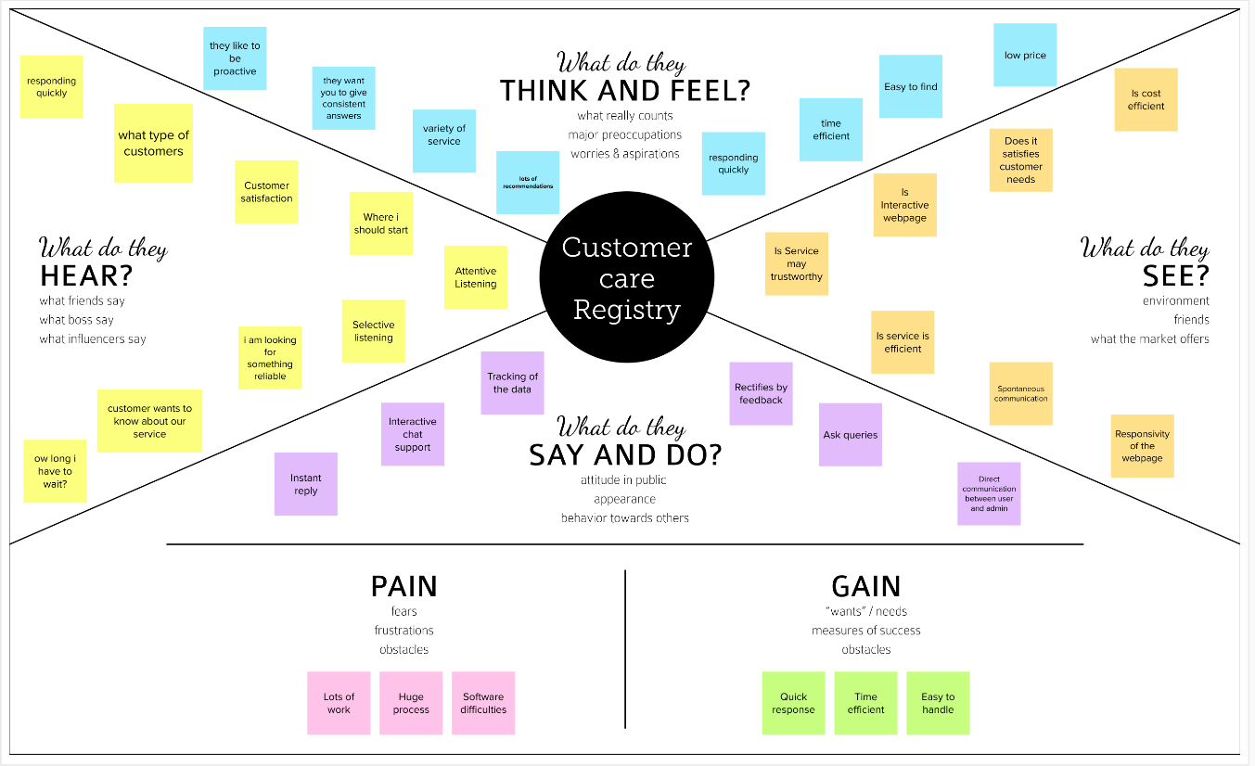

Fig 3.1: Empathy Map Canvas

* 1. **IDEATION AND BRAINSTORMING**

1. What problems are you trying to solve? Identify the problems?
2. How might can we solve the problem? Which is raised by the customer?

Brainstorming:

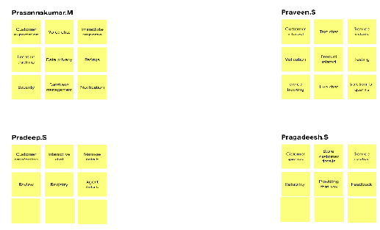

Group Ideas:

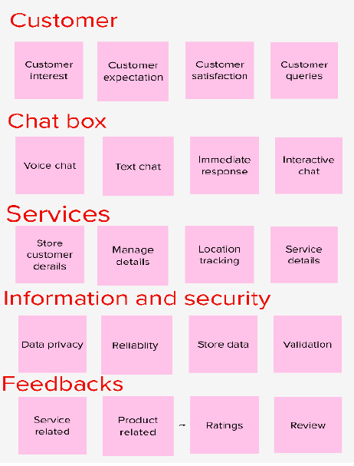

* 1. **PROPOSED SOLUTION**

Allotted Agent routing can be resolved by directly routing to a dedicated agent about the issue using the email. Automated Ticket closure by using sync of the cloud database. Status shown to the customer can display the tickets to the customer. The goal of the customer care service is to provide the platform that will allow the customer specialist to be efficient. And the solve the query with less time.

1. **REQUIREMENT ANALYSIS**

**4.1 FUNCTIONAL REQUIREMENTS**

|  |  |  |
| --- | --- | --- |
| **FR NO** | **Functional Requirement** | **Sub Registry** |
| 1 | User Registration | Registration through Form Registration through Gmail Registration through Google |
| 2 | User Confirmation | Confirmation via mail Confirmation via OTP |
| 3 | User Login | Login via Google login with Email id and password. |
| 4 | Admin Login | Login via Google login with Email id and password. |
| 5 | Query login | Description of the issues contact information. |
| 6 | E-mail | Login status |
| 7 | Feed Back | Customer Feedback |

* 1. **NON-FUNCTIONAL REQUIREMENTS**

|  |  |  |
| --- | --- | --- |
| **FR NO** | **Functional Requirement** | **Sub Registry** |
| 1 | Usability | To provide the solution to the problems |
| 2 | Security | Track of login authentication |
| 3 | Reliability | Tracking of decade status through email |
| 4 | Performance | Effective development of web application |
| 5 | Availability | 24/7 Service |
| 6 | Scalability | Agents’ scalability as per the number of customers |

1. **PROJECT DESIGN**

**5.1 DATA FLOW DIAGRAM**

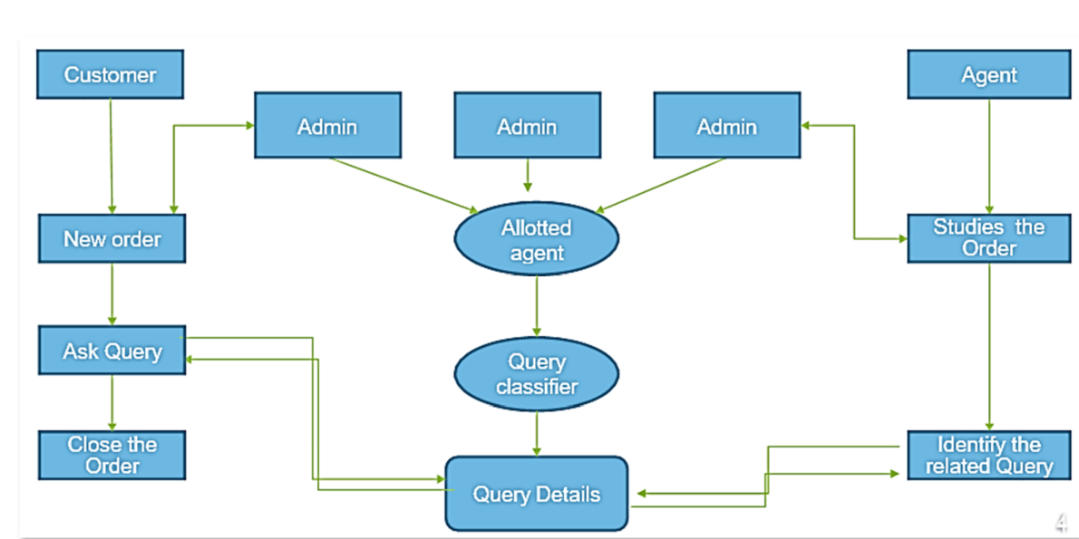

Fig 5.1: Data Flow Diagram

* 1. **SOLUTION AND TECHNICAL ARCHITECTURE**

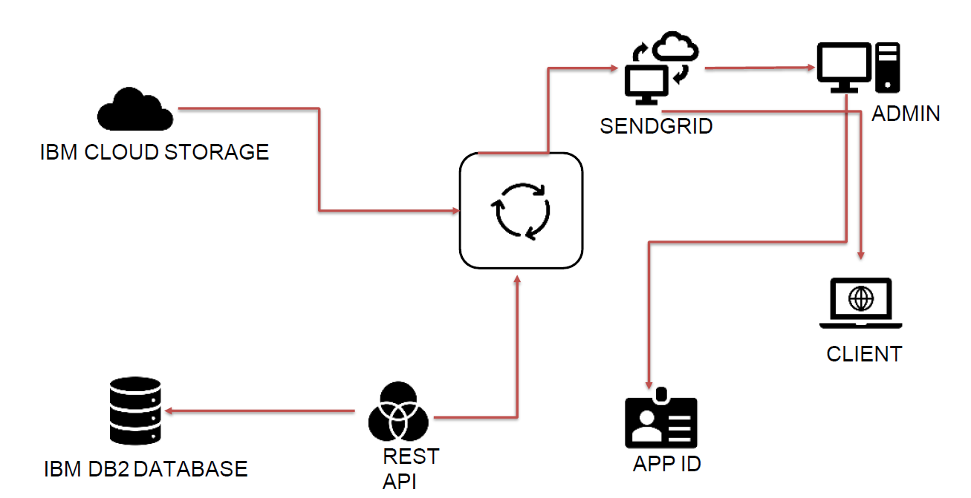

Fig 5.2: Solution and Technical Architecture

* 1. **USER STORIES**

1 User Interface - How user interacts with application e.g. WebUI, Mobile App, Chatbot etc. - HTML, CSS, JavaScript/AngularJs /React Js etc.

2 Application Logic-1 - Logic for a process in the application - Python

3 Application Logic-2 - Logic for a process in the application - IBM WatsonSTT service

4 Application Logic-3 - Logic for a process in the application IBM Watson Assistant Database - Data Type, Configurations - MySQL etc.

1. Cloud Database - Database Service on Cloud - IBM DB2,IBM Cloud etc.
2. File Storage - File storage requirements - IBM Block Storage or Other Storage Service or Local Filesystem

**6. PROJECT PLANNING & SCHEDULING**

**6.1 SPRINT PLANNING & ESTIMATION**

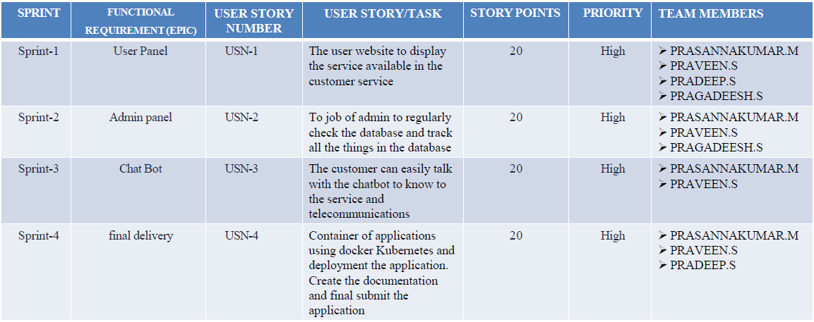

Fig 6.1: Sprint Planning & Estimation

**6.2 SPRINT DELIVERY SCHEDULE**

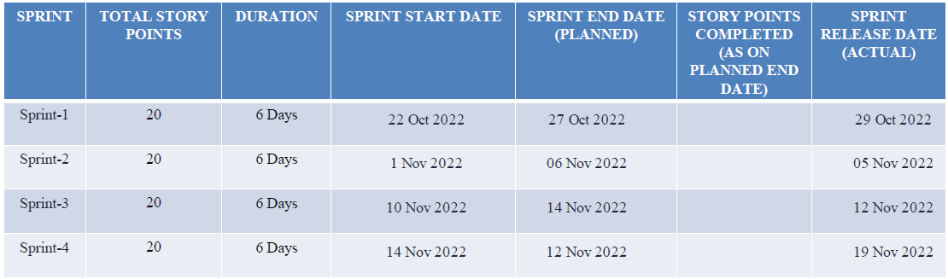

Fig 6.2: Sprint Delivery Schedule

**7. CODING & SOLUTIONING**

**7.1 FEATURE 1**

**Search Engine:**

It is a tool used to provide the search option to the job seekers like based on the functional area and location. If the job seekers select any location it shows list of all available jobs on that place.

**7.2 FEATURE 2**

**Job Calendar:**

If the user selects any date in the job calendar then it displays list of jobs available on that particular date in the same page. This feature completely developed by implementing Ajax features

**8. TESTING**

**8.1 TEST CASES**

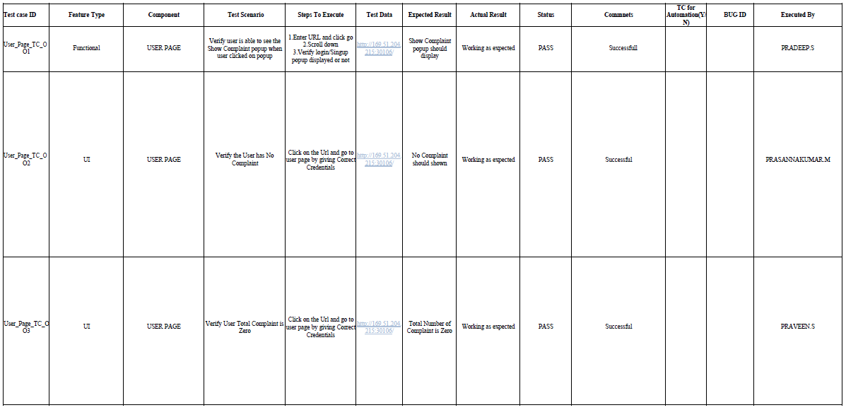

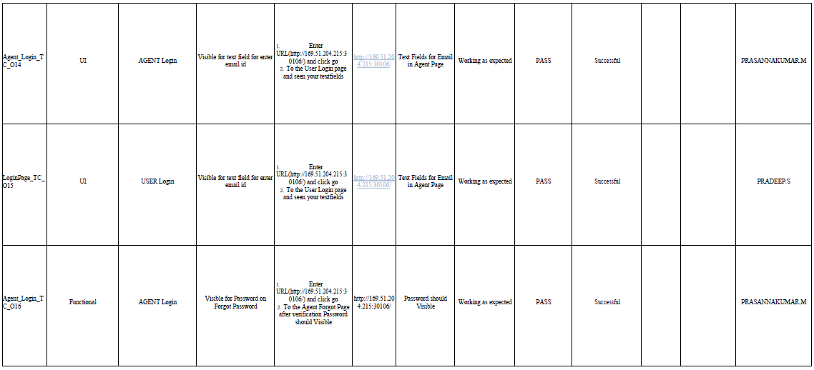

**8.2 USER ACCEPTANCE TESTING**

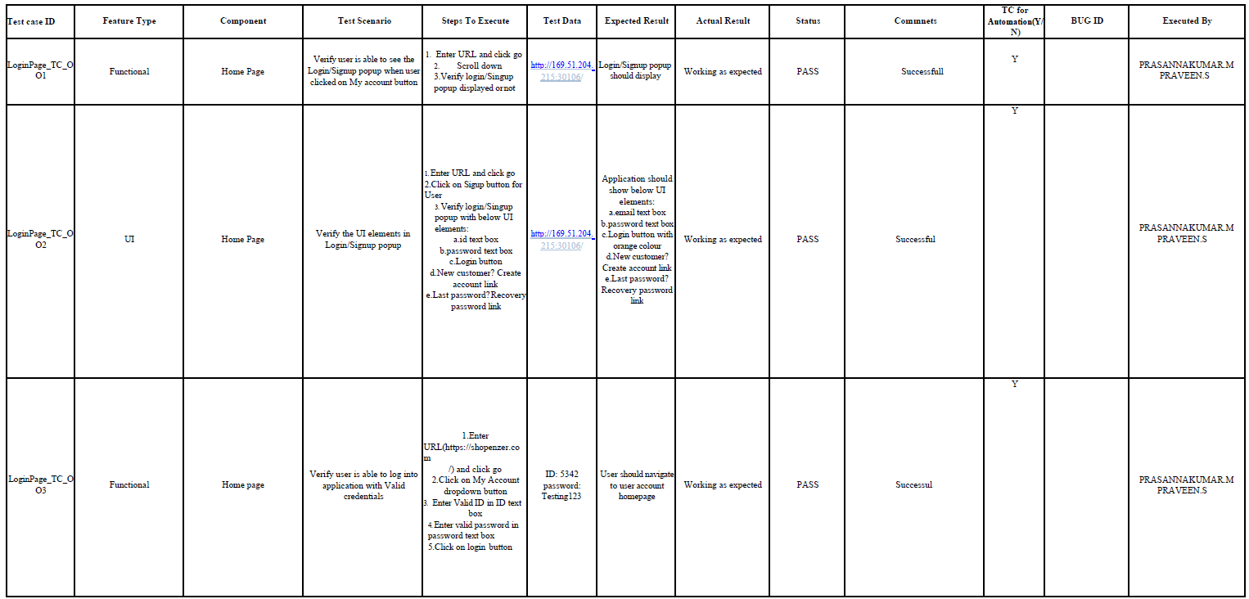

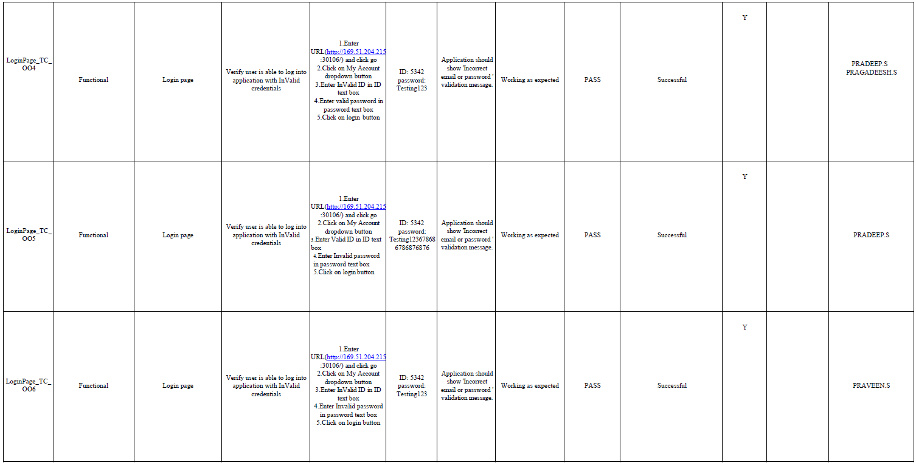

**9. CONCLUSION**

This project is designed to solve the customer queries and achieve customer satisfaction. It is a web-enabled project. With this project the details about the product will be given to the customers in detail within a short span of time. Queries regarding the product or the services will also be clarified. It provides more knowledge about the various technologies.

**10. FUTURE SCOPE**

1. Replying from the customer questions at a time.

2. It is a turning point of the marketing.

3. It will make the great revolution.

**11. APPENDIX**

**GitHub Repository Link:**

https://github.com/IBM-EPBL/IBM-Project-21734-1659789595.git